

Department of

Electrical & Electronics Engineering

**Abdullah Gül University**

**Lab 2 Report**

**EE3001 Telecommunication System Design Capsule**

**DESIGN AND TEST PROCEDURES**

In this lab, for the purpose of exploring modulation techniques, Amplitude Modulation is examined via NI Communication Suite simulation with NI-USRP 2900 (from now it will be called as USRP). First, the TX session is configured by using Lab2TX template. Figure 1 shows the first part of the function of TX. niUSRP Open Tx Session item configures the USRP for the TX session application. Next, niUSRP Configure Signal item configure a signal for USRP to use by using variables such as IQ Rate(200k), carrier frequency (915.1MHz), gain(0dB) and active antenna (TX1).

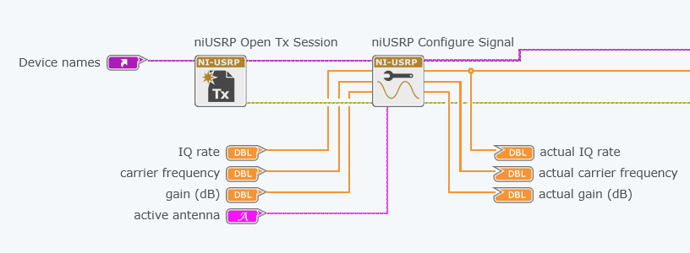

Figure 1 – Items for configuration of USRP

Secondly, as a main task of the lab, there is a function, Basic Multitone, that creates a signal, which may include different frequency tones. The produced signal then is (amplitude) modulated by carrier frequency of USRP. Here Figure 2 depicts the function of Basic Multitone and modulation script.

Figure 2 – Signal information by Basic Multitone and Modulation Math Script

Basic Multitone will create three different tones with starting frequency 1KHz and delta frequency, which means that difference between tones in amount of frequency wise, 1KHz and amplitude 1. This will create an amplitude-identical three tones with 1KHz, 2KHz and 3Khz within 200000 lengths (message length) and it will be called as message $m\left(t\right)$. Next, in Math Script, the message is used to create a modulation part, which is conventional double sideband. Before the script, to do modulation, peak of the signal is needed. To obtain peak value, $m_{p}$*,* a function which is Quick Scale is used. Moreover, there is a parameter which is called modulation index $μ$, that can be obtained from the user. Here are the Math Script operations as follows,

$$\begin{aligned}x=1+\left[μ\frac{m\left(t\right)}{m_{p}}\right] \#\left(1\right)\end{aligned}$$

$$\begin{aligned}x_{p}=\max\left(abs\left(x\right)\right) \#\left(2\right)\end{aligned}$$

$$\begin{aligned}A= \frac{x}{x_{p}} \#\left(3\right)\end{aligned}$$

$$\begin{aligned}G= Ae^{j0} \#\left(4\right)\end{aligned}$$

Eq. 1 does a calculation of x by processing $m\left(t\right)$. Then for the purpose of normalizing the x, Eq. 2., maximum value of x is found by max function, then x is divided by $x_{p}$, producing A. Lastly, A is multiplied by $e^{j0}$ to convert complex double output (CDB).

Figure 3 – While loop for the Write Tx session

Then, G is sent to niUSRP Write Tx Data to transmit the message, in Figure 3, on TX1 through the channel which is a loopback cable (Figure 4).

Figure 4 – NI 2900 USRP and Loopback cable

To capture the signal over the channel loopback is connected RX2 port of USRP. To process the message a Rx session is needed, and Lab2Rx template is used for this purpose. Here is the first part of the Lab2Rx template.

Figure 5 – Items for configuration USRP for Rx session

niUSRP Open Rx session configuring USRP for Rx part. Next niUSRP Configure Signal acts like a downconverter to demodulate the signal in RX2 port. It needs variables such as IQ Rate(1M), carrier frequency (915MHz), gain(0dB) and active antenna (RX2). After that niUSRP Initiate will open fetching operation.

Figure 6 – Fetch operation and first filter part, Bandpass with 95k low and 105k high cutoff frequencies.

The niUSRP Fetch Rx Data function acquires data and transmits it in the form of a ComplexDoubleAnalogWaveform (Figure 6). To facilitate further processing, the acquired data must be converted into the Double type and its corresponding variations. This conversion is achieved through the utilization of waveform property elements. Subsequently, the processed data, denoted as Y, is passed through a 5th-order Chebyshev Bandpass Filter, with low and high cutoff frequencies set at 95 kHz and 105 kHz, respectively. The selection of these specific frequency limits is based on the mathematical framework of modulation analysis. The Tx session sends signal on modulation with 915.1MHz signal and the Rx session demodulates the signal with 915MHz. This causes an intermediate frequency of 100KHz. As a result, the low and high cutoff frequencies are chosen for that purpose.

Subsequently, an envelope detector is required to extract the message signal. The envelope detector is implemented as a straightforward function comprising a rectifier (represented as an absolute value function within the Suite) and a low-pass filter. As illustrated in Figure 7, the output of the bandpass filter is first processed through a Complex to Real and Imaginary conversion block, as the real component is necessary for subsequent low-pass filtering. The extracted real component is then subjected to rectification via an absolute value operation, followed by low-pass filtering with a cutoff frequency of 5000 Hz. The cutoff frequency is selected based on the characteristics of the tone function used to generate the information signal, which resides within the 1 kHz to 3 kHz range.

Figure 7 – Demodulating message through envelope detector

Lastly, there is a part to plot the power spectrum of the message before the envelope detector. For this part a FFT Power Spectrum item is used (Figure 7).

**RESULTS AND DISCUSSION**

In the Tx part, Baseband signal which is message can be seen from plots (Figure 8).

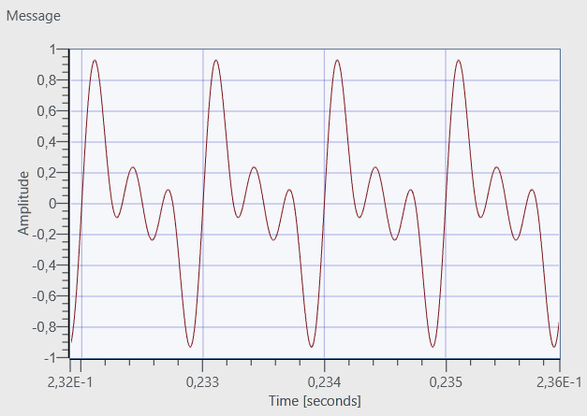

Figure 8 – Message signal generated by Basic Multitone in Tx Session.

After transmission over channel, in RX2 port the message is captured and plotted on graph. (Figure 9).

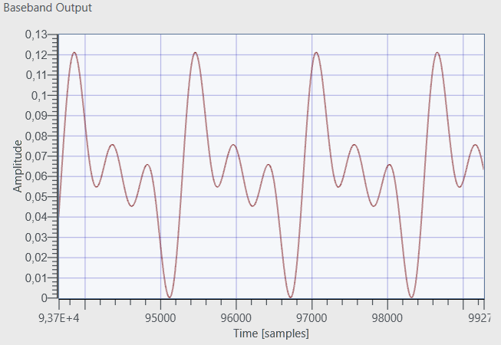

Figure 9 – Message signal on RX2 port with much lower amplitude than message on TX1 port.

Next, the information can be seen on FFT plot on RX panel for modulation index 1 (Figure 10).

Figure 10 – FFT plot of message before envelope detector, Intermediate Frequecy 100KHz and sidebands

As depicted in Figure 10, the frequency offset between the transmitter (TX) oscillator and the receiver (RX) oscillator results in the generation of an intermediate frequency (IF) of 100 kHz, subsequently producing sidebands around this IF. Furthermore, as illustrated in Figure 11, the sidebands introduced by the 1 kHz, 2 kHz, and 3 kHz components are expected to appear at specific frequency locations. More precisely, the 1 kHz component generates sidebands at 99 kHz and 101 kHz, the 2 kHz component results in sidebands at 98 kHz and 102 kHz, and the 3 kHz component produces sidebands at 97 kHz and 103 kHz.

Figure 11 – Sidebands plot and cursor measurements

As observed in Figure 10 and Figure 11, there is a power difference of 15 dB between the intermediate frequency (IF) signal and its sidebands. This result is consistent with the Prelab calculations. For the carrier power in power spectrum $\frac{D^{2}}{4}$ is used and for the sidebands $\frac{D^{2}}{144}$ used. In dB scale,

$$\begin{aligned}∆dB=20\log{ \frac{D^{2}}{4} }-20\log{ \frac{D^{2}}{144}} \#\left(5\right)\end{aligned}$$

$$\begin{aligned}=20\log{ \frac{\frac{D^{2}}{4}}{\frac{D^{2}}{144}} } \#\left(6\right)\end{aligned}$$

$$\begin{aligned}=20\log{ \frac{144}{4} }\#\left(7\right)\end{aligned}$$

$$\begin{aligned}=20\log{ \frac{144}{4}} \#\left(8\right)\end{aligned}$$

$$\begin{aligned}=20\log{ \frac{144}{4} }\#\left(9\right)\end{aligned}$$

$$\begin{aligned}=31.12 \#\left(10\right)\end{aligned}$$

However this is for one sided, the power spectrum is double sided. As a result, the difference between IF and sidebands is nearly 15dB.

To see the effect of different modulation index, $μ$ is changed to 0.5 and carrier IF and sideband power spectrum are plotted (Figure 12 and Figure 13).

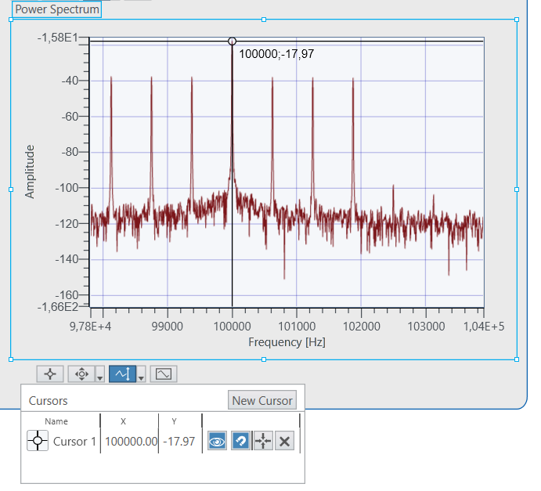

Figure 12 – Power Spectrum of Carrier IF, -17.97dB

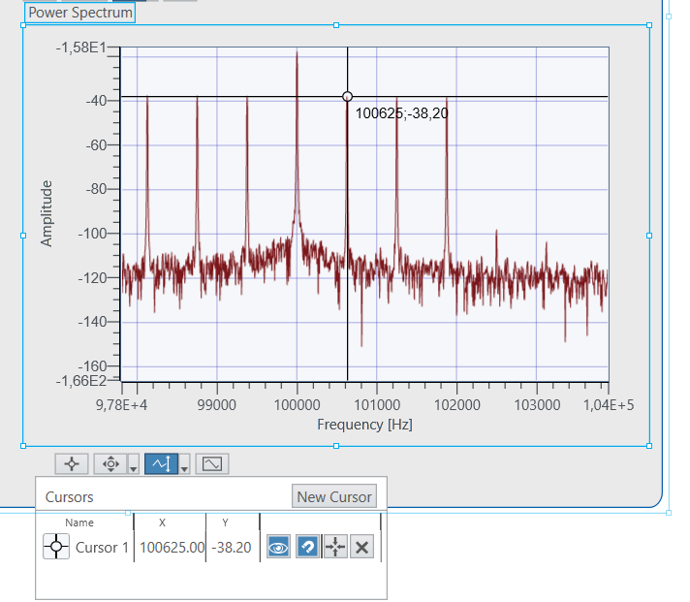

Figure 13 – Power Spectrum of Sidebands, -38.20dB

Finally, to calculate the amplitude of received signal on RX2 port a single tone in 1KHz is sent and on the RX part lowpass cutoff frequency is configured to 100Hz (Figure 14).

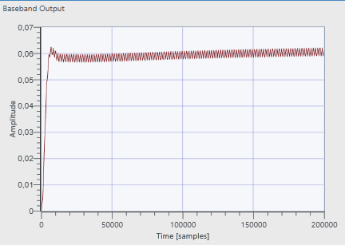

Figure 14 – DC Amplitude, 0.06

Then the gain of RX increased to 20dB to see how much change in the amplitude received (Figure 15).

Figure 15 – Amplitude received, max 0.4

In amplitude change, to verify the gain,

$$20\log{\frac{0.4}{0.06}}= 16.477dB$$

There is an error in the system; however, the RX gain amplifier has been successfully increased to approximately 20 dB, as intended.